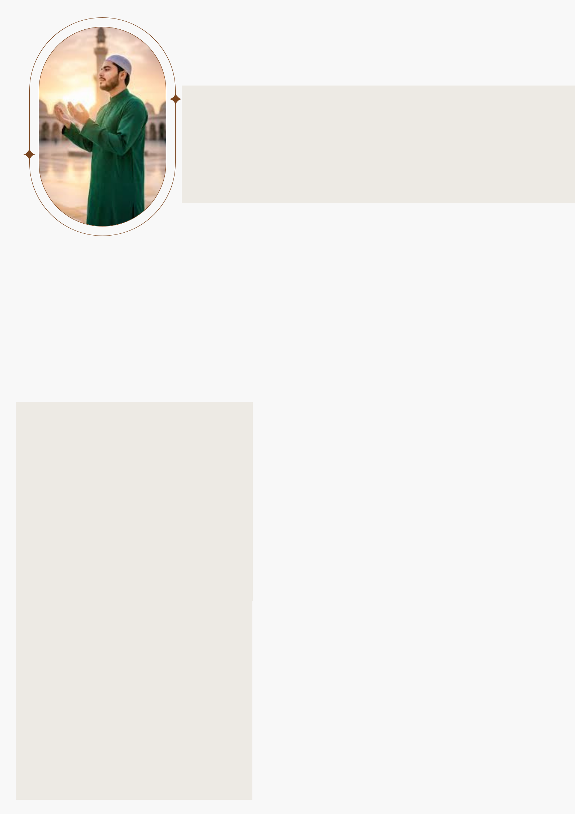
SAMEER
KHAN

Date of Birth | 22/10/2000
Place of Birth | New Dehli
Religion | Islam
Complexion | Fair
Height | 4 Feet 4 Inches
Education | Master of Computer Science
Occupation | Software Engineer

Family Details

Father’s Name Anwar Khan

Occupation Privat Job

Mother’s Name Tabassum Khan

Occupation House Wife

No. Of Brother 2

No. Of Sister 2

Contact Details

Phone No. 75678XXXXX

Address New Dehli

