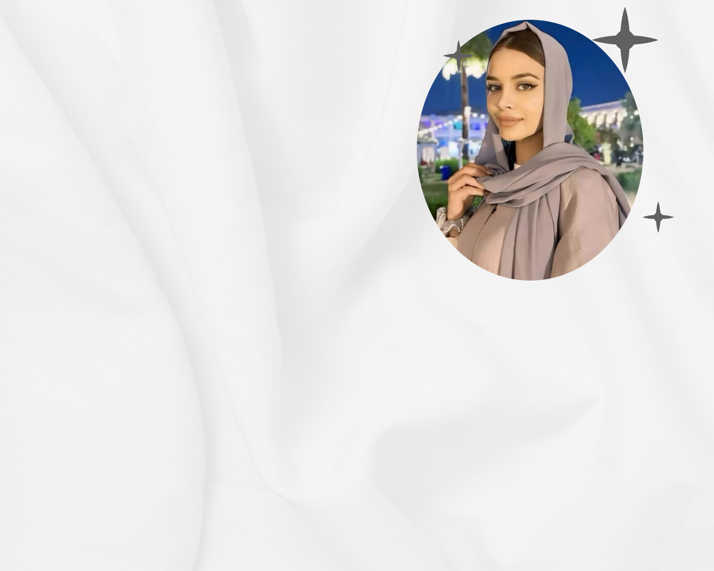
ZOYA ALI

Date of Birth | : | 22/10/2000
Place of Birth | : | New Dehli
Religion | : | Islam
Complexion | : | Fair
Height | : | 4 Feet 4 Inches
Education | : | Master of Computer Science
Occupation | : | Software Engineer

Family Details


Father’s Name | : | Irfan Ali
Occupation | : | Privat Job
Mother’s Name | : | Nargis Ali
Occupation | : | House Wife
No. Of Brother | : | 2
No. Of Sister | : | 2

Contact Details

Phone No. : 75678XXXXX

Address : New Dehli

