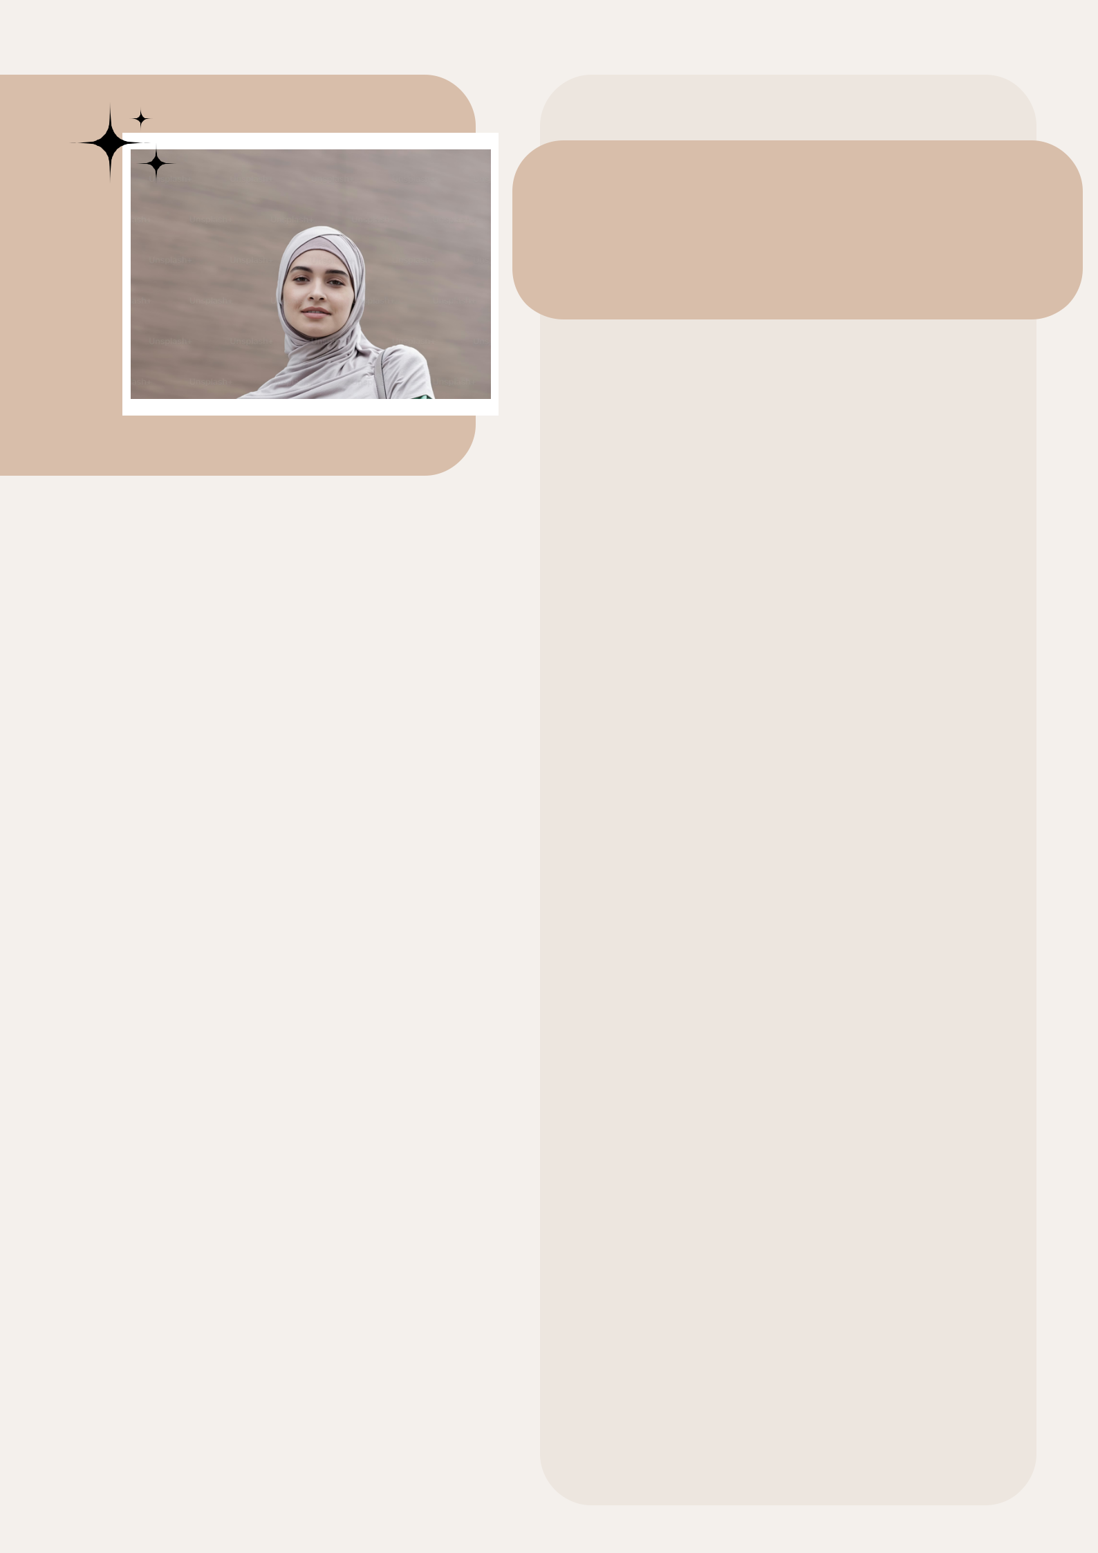
Saba Khan

Date of Birth 22/10/2000

Place of Birth New Dehli

Religion Islam

Complexion Fair

Height 4 Feet 4 Inches

Education Master of Computer Science

Occupation Software Engineer

Family Details

Father’s Name Anwar Khan

Occupation Privat Job

Mother’s Name Tabassum Khan

Occupation House Wife

No. Of Brother 2

No. Of Sister 2

Contact Details

Phone No. | 75678XXXXX
Address | New Dehli

